Invoices — IDOR (Insecure Direct Object Reference)
Proof of Concept Report — HackViser Lab
Prepared by: Aakash Singh | Date: May 31, 2026

Vulnerability Information

Author | Aakash Singh
Date | May 31, 2026
Lab | Invoices — IDOR (Insecure Direct Object Reference)
Platform | HackViser
Vulnerability Type | IDOR — Unauthorized Invoice Access
Severity | High
CWE | CWE-639
Impact
An attacker can access invoices/billing documents of other users by manipulating the invoice/user ID parameter, leading to unauthorized disclosure of financial and personal data.
Reproduction Steps
Step 1: Log in to the application and navigate to the Invoices section.
Step 2: Observe that the invoice URL or request contains a user ID parameter (e.g., userID=1001).
Step 3: Capture the invoice request using Burp Suite HTTP history.
Step 4: Modify the userID from 1001 to 1003 in Burp Repeater.
Step 5: Send the modified request — observe 200 OK response.
Step 6: Copy the response link and open it in the browser to view the PDF invoice.
Step 7: Another user's invoice (billing PDF) is now accessible — IDOR confirmed.
Evidence Screenshots
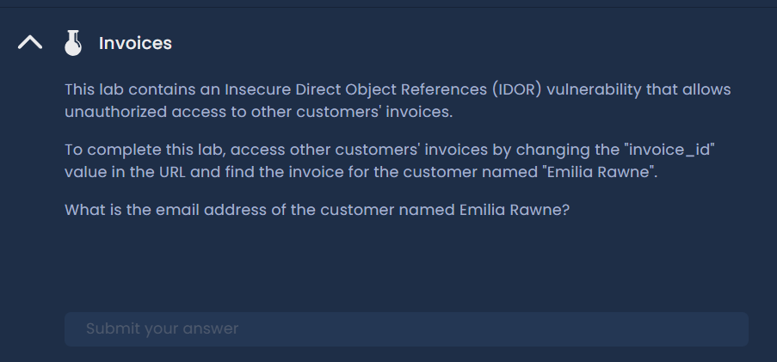
Figure 1: Invoices section — initial page
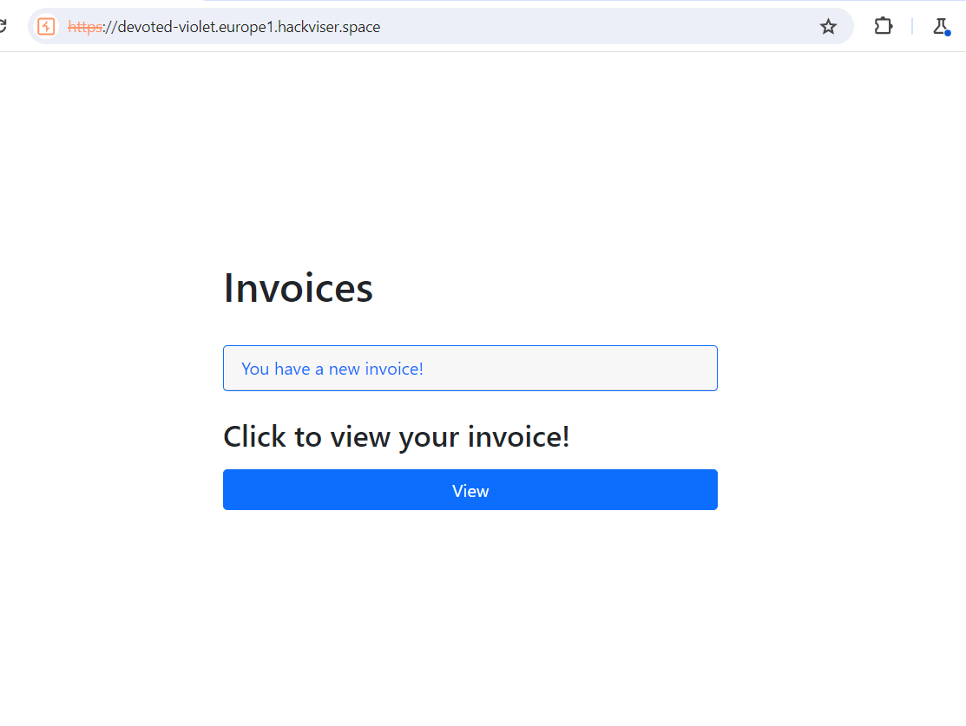
Figure 2: Invoice request showing userID parameter
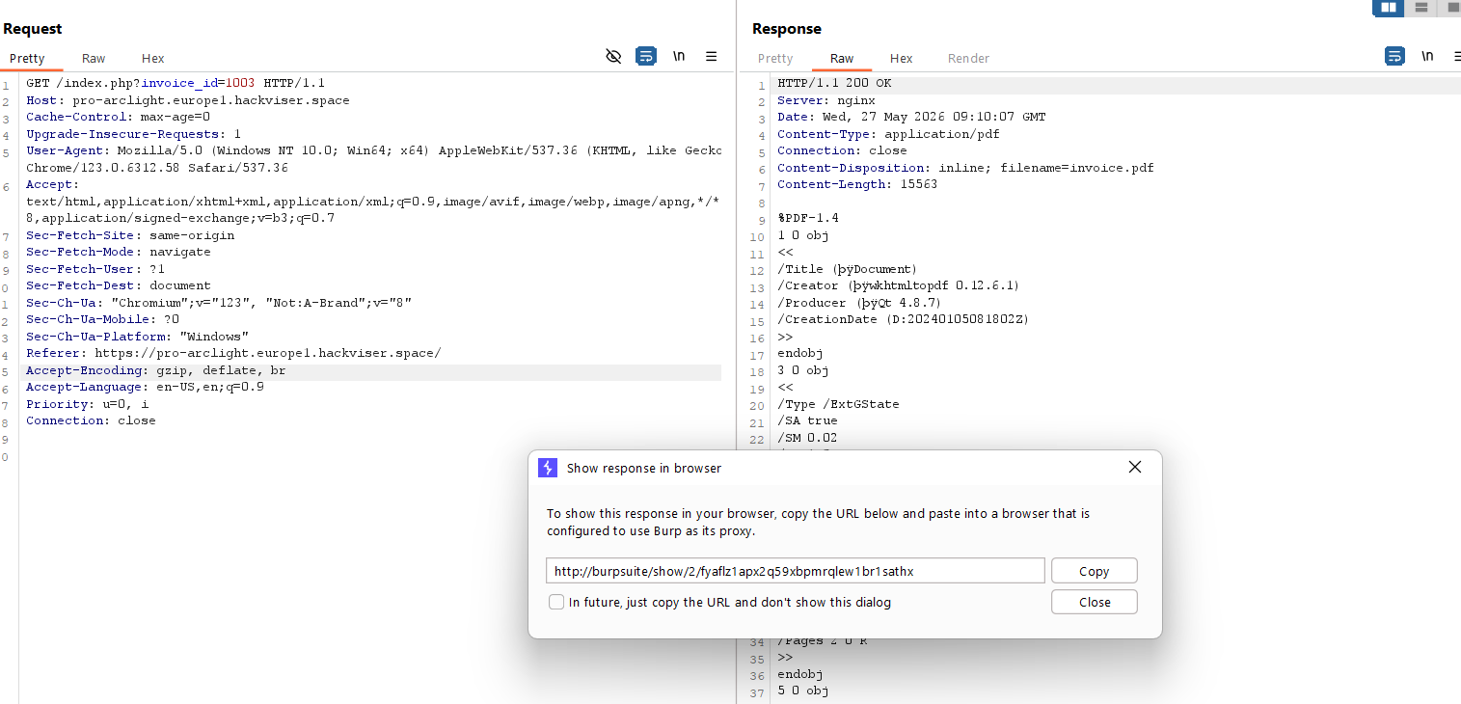
Figure 3: userID modified from 1001 to 1003 — 200 OK response
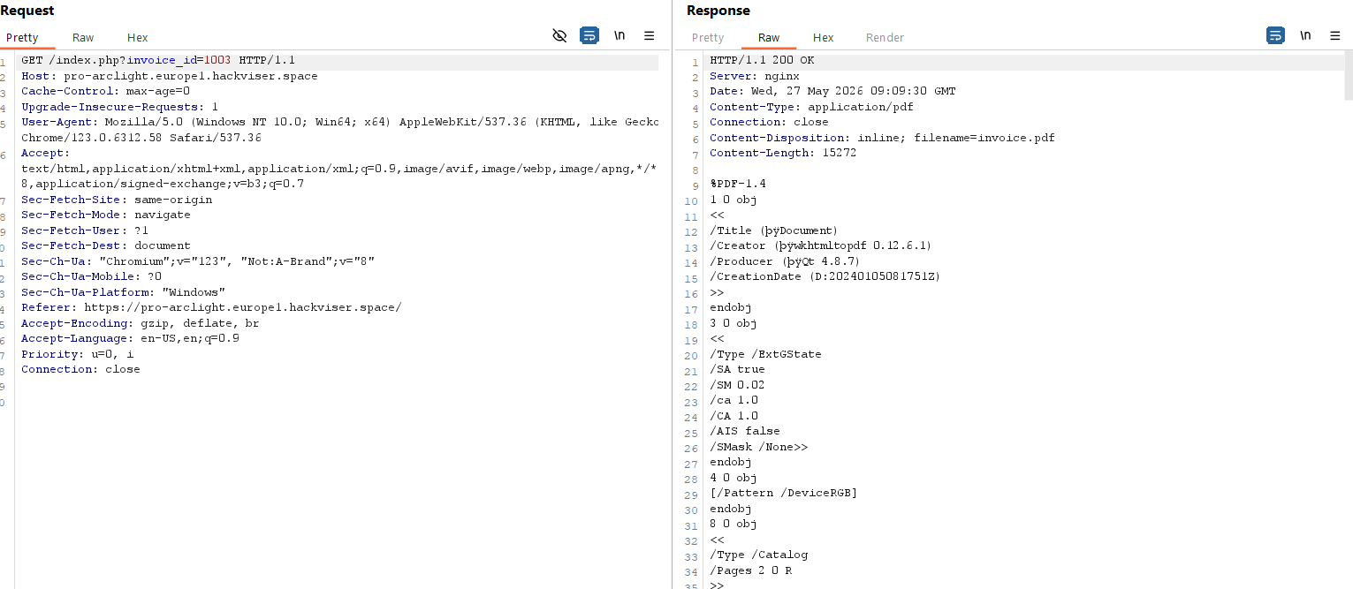
Figure 4: PDF invoice of another user displayed
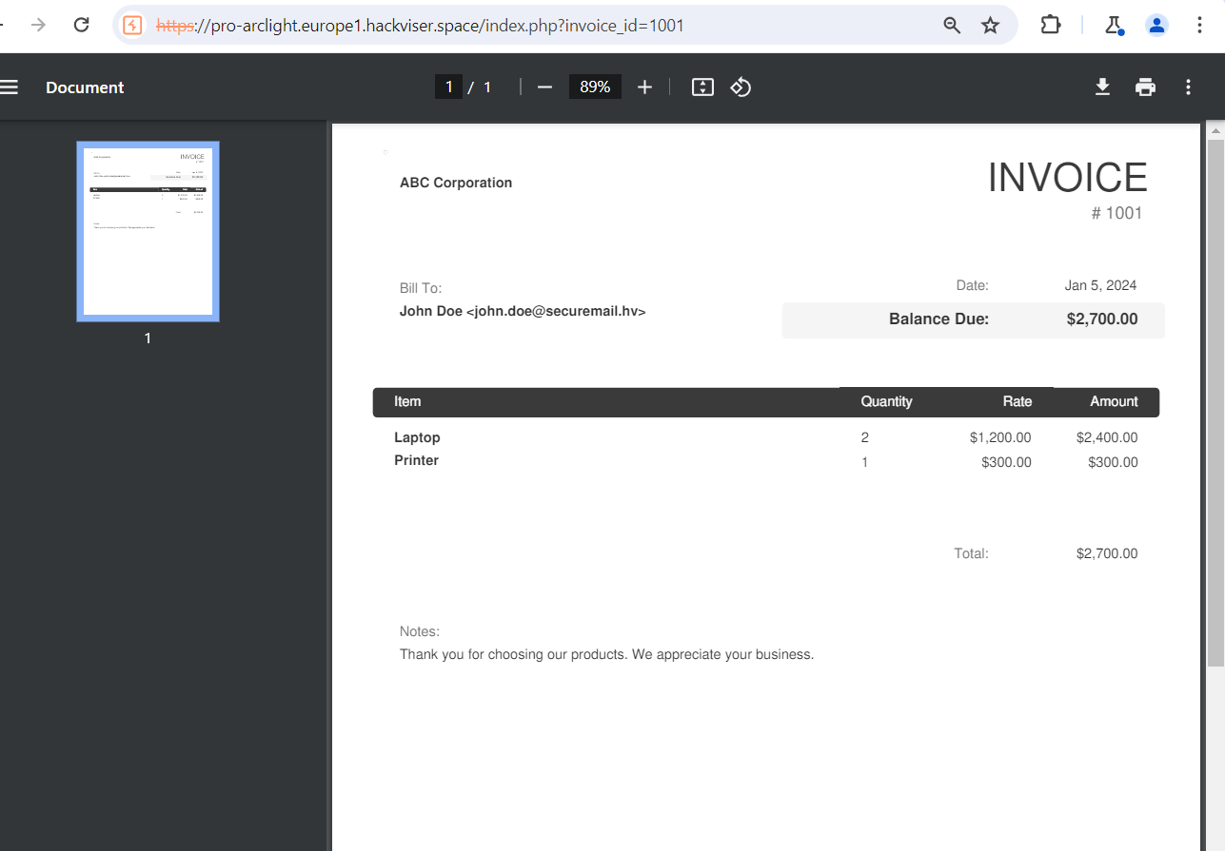
Figure 5: Invoice URL retrieved from HTTP history
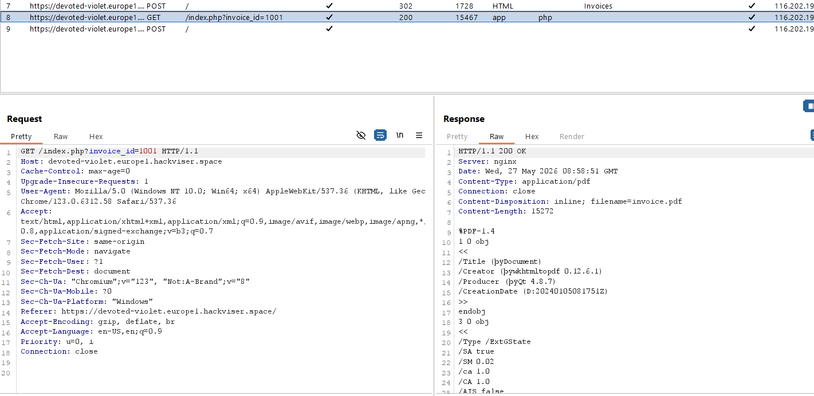
Figure 6: Opened PDF in browser — unauthorized billing data
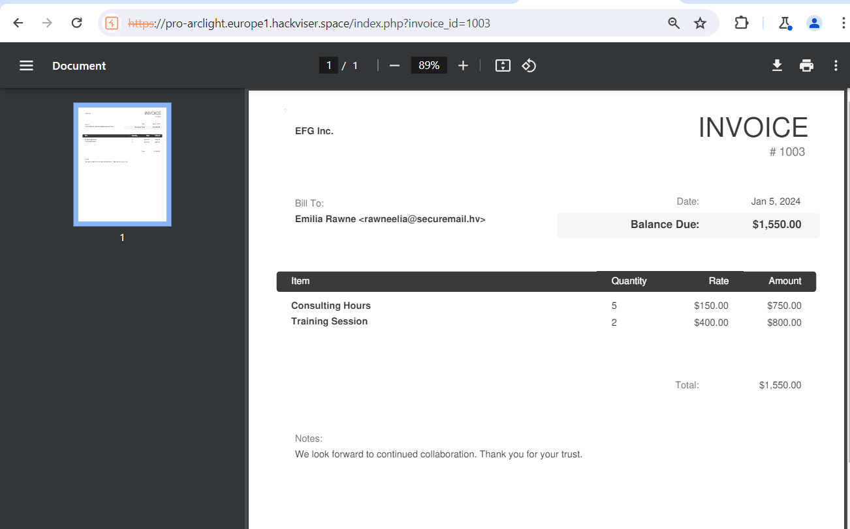
Figure 7: Lab solved — IDOR vulnerability confirmed
Remediation
Implement proper authorization checks to verify the requesting user owns the resource. Use indirect references mapped server-side rather than exposing direct database IDs.
Confidential — Prepared by Aakash Singh | Security Research POC

